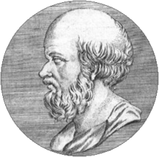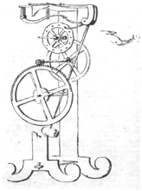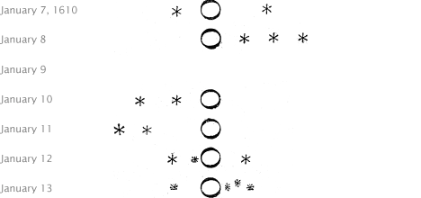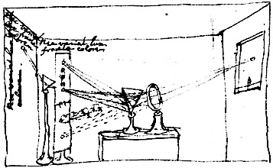

**12 Experiments That Changed Our World**

Harvard University General Education Course to be taught in the Spring of 2020

Philip Sadler, Ed.D., F.W. Wright Senior Lecturer in Astronomy

Facing the edifice of preexisting knowledge, how are breakthrough scientific discoveries made that contradict the existing canon? Twelve great experiments that have transformed our understanding of nature will guide us, first through immersion in the scholarship and popular beliefs of the time. Next, how did the discoverer prepare? What were the motivations, prior experiences, and training that led to the threshold of a fruitful advance? Then, to the degree possible, we will carry out the exact same investigations, building our own simple equipment from scratch, duplicating the challenges of wresting patterns from noisy and incomplete data. Students will compare their results to both private and published versions of the original research. The course will examine the magnitude of the cognitive shifts experienced and the often uphill battle to acceptance. We will build an understanding of the nature of scientific progress, examining how the mastery of natural phenomena leads to new technologies and how these can contribute to further scientific discovery.   
  
Experiments are drawn from the natural sciences, ancient to modern, from Eratosthenes measuring the earth’s size to Rosalind Franklin determining the structure of DNA. We will consider how these discoveries continue to impact society, as well as the many ethical questions raised. The course will examine the difficulty of accepting new experimental evidence falsifying accepted scientific paradigms and how this remains an issue that plays out in current society. By unpacking these 12 experiments, students will be able to better prepare for their own future discoveries and contributions.

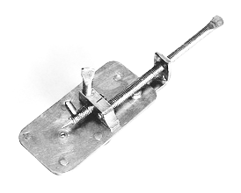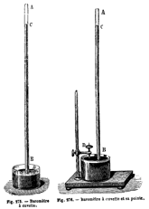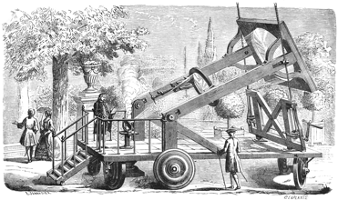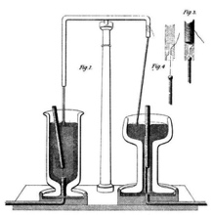

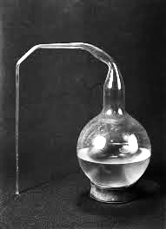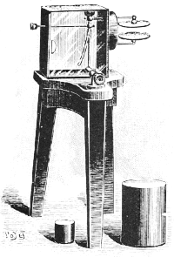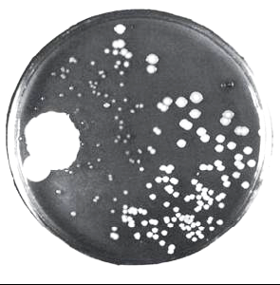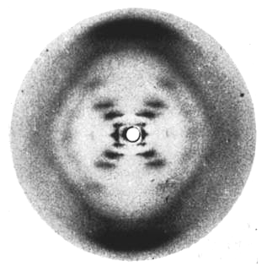

*I designed and the experiments, curated the readings, and wrote the material for the units associated with Louis Pasteur’s swan neck flask experiment and*

*Alexander Fleming development of penicillin.*